DESIGN AND ANALYSIS OF ALGORITHMS
ASSIGNMENT 1
CO1: Algorithm fundamentals, efficiency analysis, asymptotic analysis, mathematical analysis, recurrence analysis, Master Theorem, substitution, etc.

Assignment Title: Design, Analyse and Validate an Efficient Search Strategy for a Large-Scale Student Record System (Total Marks - 50)
Duration:1week

Scenario — University Student Record Retrieval

A university maintains a large academic database containing student records, each identified by a unique Registration Number. Faculty and administrative staff frequently need to determine whether a particular student record exists and retrieve the corresponding information.
The database may contain:

1,000 → 10,000 → 100,000 → 1,000,000+ records

You are required to investigate, design and compare efficient algorithmic approaches for locating a given registration number as the database grows.
Your solution must remain practical for both small and very large datasets. Any preprocessing performed on the records must be included in your efficiency analysis.

Design Challenge:

The university now needs to process 50,000 search requests per hour on a database containing 1,000,000 student records. New student records are added only once per day.
Re-evaluate your original design and determine whether it should be retained, modified or redesigned.
TASK 1 – Design the Algorithm 5 Marks
Design and propose at least three meaningfully different algorithmic strategies for locating a given registration number.
The three approaches must represent distinct algorithmic strategies. Iterative and recursive implementations of the same underlying algorithm will not be considered as two different approaches.
Your proposed approaches must include:

- At least one iterative approach
- At least one recursive approach
- A clear explanation of the basic idea behind each approach
- Pseudocode or an appropriate flowchart for each approach
- A brief justification for selecting each approach for investigation
- Any preprocessing required by the approach, such as sorting or restructuring the data
You are expected to design and select the approaches independently. The appropriateness and diversity of the selected algorithmic strategies form part of the assessment.

Evidence Expected

Three meaningfully different algorithmic strategies, supported by pseudocode/flowcharts, identification of the design strategy, preprocessing requirements, and justification for selecting each approach.

TASK 2 – Identify the Basic Operation 2 Marks
For each of the proposed algorithms, identify the basic operation that predominantly determines its execution time.
Discuss:

- What the basic operation is
- Where it occurs in the algorithm
- Why it is appropriate to use this operation for efficiency analysis
- How the number of times it executes may change as the input size (n) increases

Do not simply name an operation. You are expected to relate the selected operation to the behaviour of the algorithm.

Evidence Expected

Correct identification and justification of the dominant/basic operation for each proposed algorithm.

TASK 3 – Derive the Time-Complexity Function Mathematically 6 Marks
Derive the time-complexity function for each proposed approach using mathematical analysis.
Discuss:

- The input size (n)
- The number of times the basic operation executes
- How the operation count changes with (n)
- The mathematical expression representing the running time
- Any preprocessing cost involved
- The overall cost when preprocessing and searching are considered together You must show the mathematical reasoning leading to the complexity result. Merely stating that an algorithm is (O(n)), (O(\log n)), etc., will not receive full credit. Evidence Expected
A clear mathematical derivation of the time-complexity function for each approach, including relevant operation counts and preprocessing costs.

TASK 4 – Analyse Best, Average and Worst-Case Behaviour 4 Marks Analyse the performance of each algorithm under different input conditions. Discuss, wherever applicable:
- What input condition produces the best case
- What input condition produces the average case
- What input condition produces the worst case
- How the number of operations changes in each case
- Why these differences occur

Do not simply provide a table containing complexity values. You are expected to explain the conditions that lead to each case.

Evidence Expected

A justified best-, average- and worst-case analysis for the proposed approaches, supported by appropriate mathematical reasoning.

TASK 5 – Perform Asymptotic Analysis 3 Marks
Express and compare the growth behaviour of your proposed algorithms using appropriate asymptotic notation.
Discuss:

- Appropriate use of (O), (\Omega) and/or (\Theta), wherever relevant
- How each algorithm behaves as (n) becomes very large
- How the growth rates of the proposed approaches differ
- What the growth behaviour means when the dataset increases from 1,000 to 1,000,000+ records
You are expected to interpret the asymptotic behaviour in the context of the given application, rather than merely state the notation.

Evidence Expected

Correct asymptotic representation and a meaningful comparison of the growth behaviour of the proposed approaches.

TASK 6 – Formulate the Recurrence Relation 3 Marks
For the recursive approach, formulate a recurrence relation directly from the behaviour of the algorithm.
Clearly identify:

- The size of the recursive subproblem
- The number of recursive calls
- The work performed outside the recursive call
- The base case
- How these components lead to the recurrence relation

The recurrence must be derived from your algorithm, rather than simply writing a known recurrence formula.

- The input size of the original problem

Evidence Expected

A correctly formulated recurrence relation with clear identification of its components and base case.

TASK 7 – Solve the Recurrence Relation 4 Marks
Solve the recurrence relation obtained in Task 6 using an appropriate analytical method. You may use:
- Substitution method
- Iteration method
- Master Theorem
- Another appropriate analytical technique Discuss:
- Why the selected method is applicable
- The steps involved in solving the recurrence
- The resulting complexity
- What the result indicates about the behaviour of the recursive algorithm as (n) increases
You are expected to show the analytical process, rather than provide only the final complexity.

Evidence Expected

A complete recurrence solution using an appropriate method, together with justification of the method and interpretation of the result.

TASK 8 – Implement and Test the Algorithms 4 Marks
Implement all the proposed algorithmic approaches and experimentally test their behaviour.
Use datasets of approximately:

1,000 → 10,000 → 100,000 → 1,000,000 records

Ensure that:

- All algorithms produce the correct result
- The same or equivalent datasets are used for comparison
- Testing conditions are kept reasonably consistent
- Appropriate test cases are included
- The implementation corresponds to the algorithms analysed in the previous tasks

The purpose of implementation is not merely to demonstrate working code, but to generate evidence for validating your theoretical analysis.

Evidence Expected

Working implementations of the proposed algorithms together with a clearly described and reproducible testing procedure.

TASK 9 – Record Experimental Performance 3 Marks
Collect and present experimental performance data for each algorithm across the different input sizes.
Record appropriate measures such as:

- Execution time
- Number of comparisons
- Number of key operations
- Input size
- Other relevant performance measures, where justified Present the results using appropriate:

- Tables
- Graphs
- Performance plots

Ensure that the presentation allows the different approaches to be easily compared.

Evidence Expected

Systematically collected experimental data presented clearly using appropriate tables and/or graphs.

TASK 10 – Compare Theory with Experimental Behaviour 4 Marks
Compare your theoretical analysis with your experimental results. Discuss:
- Whether the observed growth agrees with the theoretical complexity
- Which algorithm scales better as (n) increases
- Any differences between theoretical prediction and actual execution
- Possible reasons for the differences

You are expected to interpret the results, rather than simply reproduce tables or graphs.

Evidence Expected

A reasoned comparison between theoretical and experimentally observed performance.

TASK 11 – Recommend and Defend the Final Design 4 Marks
Based on your mathematical analysis and experimental findings, recommend the most appropriate algorithmic solution for the university student-record system.
Discuss:

- Which approach you recommend
- Why it is more appropriate than the alternatives
- Its theoretical efficiency
- Its experimentally observed performance
- Any preprocessing cost involved

- Relevant trade-offs or limitations
- Whether the solution remains practical as the database grows

Your recommendation must be based on evidence obtained from your own analysis and experimentation.
Simply identifying the algorithm with the lowest Big-O complexity is not sufficient.

Evidence Expected

A technically justified final design recommendation supported by both mathematical analysis and experimental evidence.

DAY-4 DESIGN CHALLENGE
TASK 12 – Re-evaluate and Adapt the Design 8 Marks

Changed Requirement

The university now needs to process 50,000 search requests per hour on a database containing 1,000,000 student records.
However, new student records are added only once per day.

Re-evaluate your original design in response to these changed operating conditions. You may:
RETAIN → MODIFY → or REDESIGN

your original solution.

Impact Analysis – 2 Marks

Discuss:

  - What has changed from the original problem
  - Which original assumptions are affected
  - Why the frequency of searches is now important
  - Why the relatively low frequency of record updates may influence the design

Evidence Expected

A clear analysis of how the changed requirements affect the original algorithmic design.

Evaluation of the Original Design – 2 Marks

Evaluate whether your original recommended solution remains appropriate. Discuss:
  - Its expected behaviour under 50,000 searches per hour
  - Whether its preprocessing cost is acceptable under the new conditions
  - Whether another approach could provide better overall performance

Evidence Expected

A technically supported evaluation of the suitability of the original design under the new operating conditions.

Adaptation or Redesign – 2 Marks

Decide whether to:

Retain, modify or redesign the original solution. If you modify or redesign it:
  - Describe the revised algorithmic strategy
  - Explain what has changed
  - Determine the effect on computational complexity

If you retain the original solution, provide sufficient technical justification for why no redesign is necessary.

Evidence Expected

An appropriate design response to the changed requirement, with clear algorithmic reasoning.

Evidence-Based Defence – 2 Marks

Defend your final design decision using evidence. Use:
  - Mathematical complexity analysis

  - Experimental results, where appropriate
  - Search frequency
  - Preprocessing cost
  - Dataset size
  - Relevant computational trade-offs

Your final decision must follow logically from your analysis.

Evidence Expected

A well-supported final design decision integrating theoretical analysis, experimental evidence and the changed system constraints.

Scenario – University Student Record Retrieval.
Task | Requirement | Marks
Task 1 | Design at least three different search strategies (one iterative, one recursive) with idea, pseudocode/flowchart, preprocessing and justification | 5
Task 2 | Identify the basic operation of each algorithm and justify it | 2
Task 3 | Derive the time-complexity function mathematically (including preprocessing) | 6
Task 4 | Analyse best, average and worst cases with conditions | 4
Task 5 | Perform asymptotic analysis (O, Ω, Θ) and interpret growth from 1,000 to 1,000,000+ | 3
Task 6 | Formulate the recurrence relation of the recursive approach | 3
Task 7 | Solve the recurrence (substitution / iteration / Master Theorem) | 4
Task 8 | Implement and test all algorithms on 1,000 → 1,000,000 records | 4
Task 9 | Record experimental performance (tables and graphs) | 3
Task 10 | Compare theory with experimental behaviour | 4
Task 11 | Recommend and defend the final design | 4
Task 12 | Day-4 Design Challenge: (A) Impact analysis, (B) Evaluation of original design, (C) Adaptation or redesign, (D) Evidence-based defence (2 marks each) | 8
 | TOTAL | 50

TASK 1 – Design the Algorithm
Each record has a unique integer key (registration number). Three different strategies are selected. Approach B is the recursive one and Approach A is the iterative one.
Approach | Design strategy | Style | Preprocessing needed | Search cost (worst case)
A. Linear search | Brute force | Iterative | None | n comparisons
B. Binary search | Decrease-and-conquer (halve the range) | Recursive | Sort the records once (merge sort) | ⌊log₂ n⌋ + 1 comparisons
C. Hash table with chaining | Space–time trade-off (hashing) | Iterative (scan one short chain) | Build the hash table once | 1 on average, n worst
Table 1: Summary of the three approaches

Approach A – Linear Search (Brute Force, Iterative)
Basic idea: Start at the first record and compare each registration number with the key K, one after the other, until K is found or the records finish. Preprocessing: none – the records can stay unsorted. Why selected: it is the simplest correct method and acts as the baseline; it works on unsorted data and is perfectly acceptable for small databases (about 1,000 records).
ALGORITHM LinearSearch(A[0..n-1], K)
for i ← 0 to n-1 do
if A[i] = K then return i
return -1

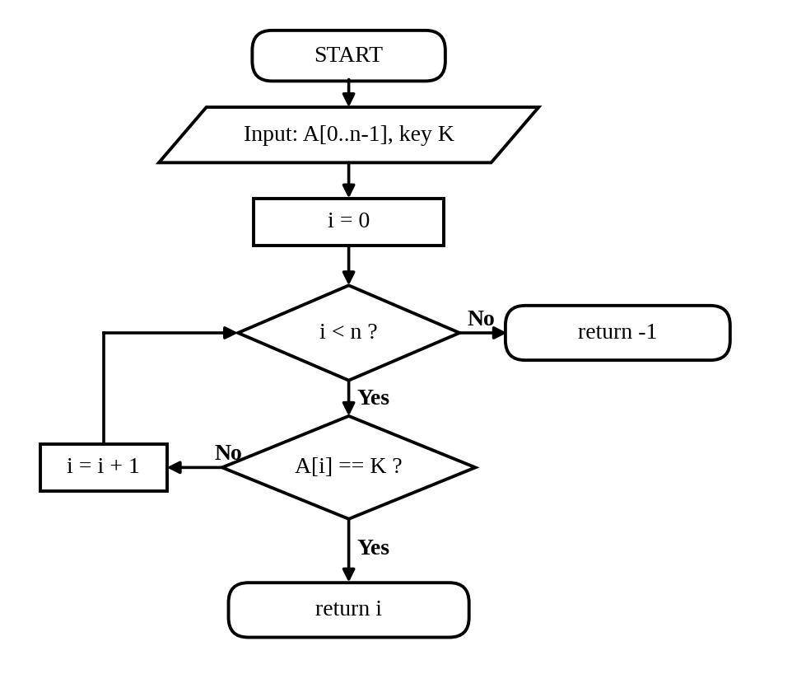
Figure 1: Flowchart of linear search

Approach B – Binary Search (Decrease-and-Conquer, Recursive)
Basic idea: Look at the middle record of a sorted list. If it equals K, stop. If K is smaller, search only the left half; otherwise search only the right half. Every comparison throws away half of the remaining records. Preprocessing: the records must be sorted by registration number once (merge sort, about n log₂ n comparisons). Why selected: it exploits ordering to cut the search space very fast, and it is the natural recursive solution.
ALGORITHM BinarySearch(A[0..n-1], K, low, high)
// A is sorted. First call: low = 0, high = n-1
if low > high then return -1
mid ← ⌊(low + high) / 2⌋
if A[mid] = K then return mid
else if K < A[mid]
return BinarySearch(A, K, low, mid-1)
else return BinarySearch(A, K, mid+1, high)

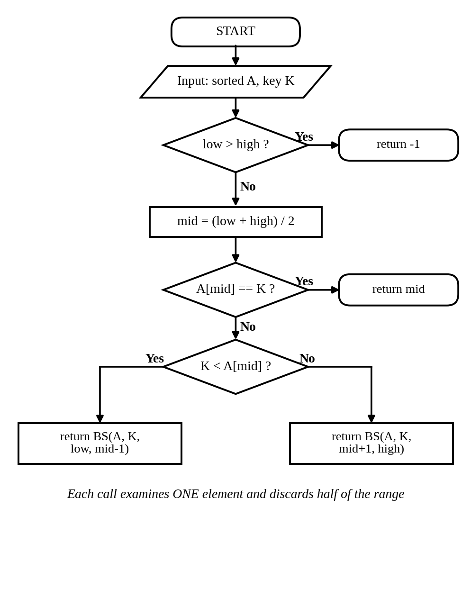
Figure 2: Flowchart of recursive binary search

Approach C – Hash Table with Chaining (Hashing)
Basic idea: Do not search at all – calculate where the record must be. A hash function idx = K mod m gives a slot in a table of size m. Records that fall in the same slot are kept in a short chain (collisions). Preprocessing: build the table once by inserting every record (Θ(n)). Why selected: it is a completely different idea (direct address calculation instead of comparing and eliminating) and gives the fastest average search, at the cost of extra memory (m ≈ 1.3 n slots).
ALGORITHM BuildTable(R[0..n-1], m) // preprocessing
for j ← 0 to m-1 do T[j] ← empty list
for i ← 0 to n-1 do
append R[i] to T[ R[i] mod m ]

ALGORITHM HashSearch(T, K, m)
idx ← K mod m
for each x in T[idx] do
if x = K then return FOUND
return NOT FOUND

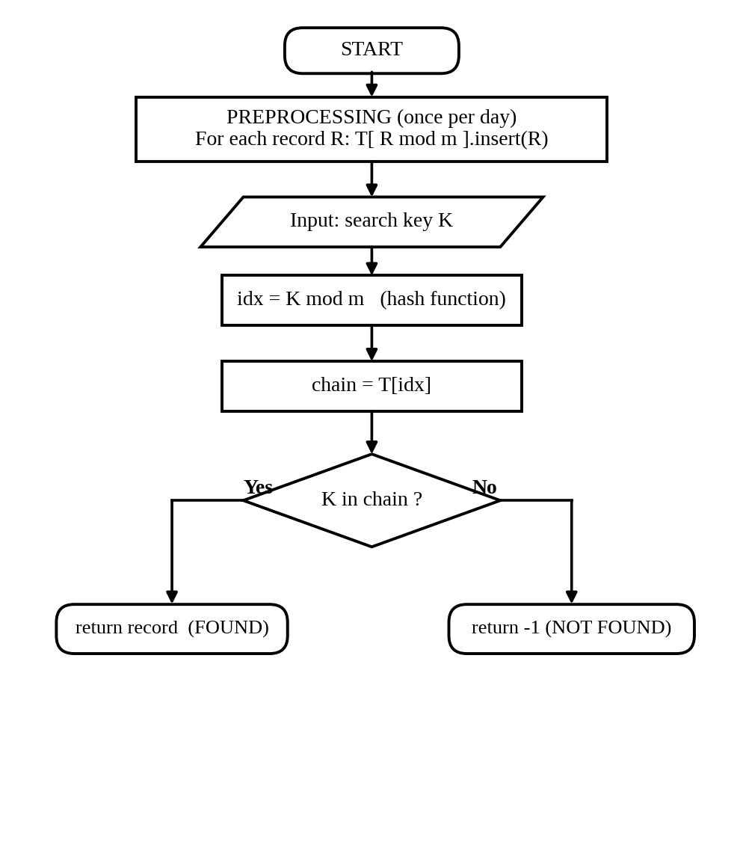
Figure 3: Flowchart of hash-table search with its preprocessing step
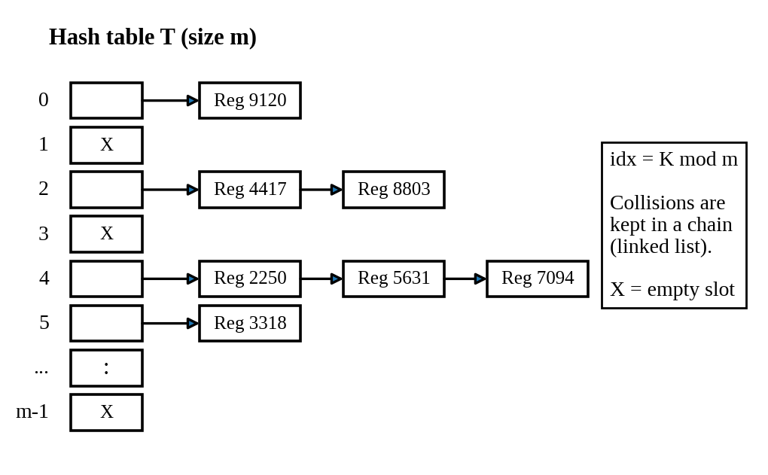
Figure 4: Structure of the hash table (chaining)

TASK 2 – Identify the Basic Operation (2 Marks)
The basic operation is the operation executed most often and in the innermost part of the algorithm, so that the total running time is roughly proportional to the number of times it is executed. In a search problem the work that decides the speed is comparing the key K with a stored registration number.
Algorithm | Basic operation | Where it occurs | How its count changes as n grows
A. Linear search | Comparison A[i] = K | Inside the for-loop, once in every iteration | Grows in direct proportion to n: about n/2 on average and n in the worst case. 1,000 times more records means about 1,000 times more comparisons.
B. Binary search | Comparison A[mid] = K (one three-way comparison with the middle key per call) | In every recursive call, right after mid is calculated | Grows very slowly: the range is halved each time, so the count is about log₂ n. Doubling n adds only one extra comparison.
C. Hash table | Comparison x = K while scanning the chain T[idx] | Inside the loop of HashSearch | Almost independent of n: chain length depends on the load factor α = n/m (about 0.77), not on n itself.
Table 2: Basic operation of each algorithm

Why is this operation appropriate?
- It is the only operation that repeats with the input size. Other statements (setting i = 0, returning a result, computing mid or the hash index) are executed a fixed number of times per search or once per call.
- In every algorithm each repetition of the loop or recursive call performs exactly one key comparison, so counting comparisons counts the repetitions. This makes the result independent of the computer and the programming language.
- Comparing registration numbers is also the operation that distinguishes the algorithms: linear search needs many, binary search needs few because every comparison removes half the data, and hashing needs about one because the hash function has already narrowed down the position.
- Preprocessing: for binary search the basic operation of the sorting step is also a key comparison (merge sort); for the hash table it is the insertion of one key (one hash calculation and one append), executed n times.

TASK 3 – Derive the Time-Complexity Function (6 Marks)
Input size: n = number of student records in the database. Basic operation: one key comparison. q denotes the number of searches performed.

A. Linear search
The loop compares A[0], A[1], … in order. If the key is at position i (counting from 1), exactly i comparisons are made. If the key is absent, all n records are compared.
C_worst(n) = Σ (i = 0 to n−1) 1 = n
If the key is present and each position is equally likely (probability 1/n):
C_avg(n) = (1/n) · Σ (i = 1 to n) i = (1/n) · n(n+1)/2 = (n + 1) / 2
If the key is present with probability p: C_avg(n) = p(n+1)/2 + (1 − p)·n. Preprocessing cost = 0. Total for q searches = q·(n+1)/2 on average. For n = 1,000,000 this is about 500,000 comparisons per search.

B. Binary search
Searching. Let the range size be n. After the first comparison at most ⌊n/2⌋ records remain, after the second at most ⌊n/4⌋, and after k comparisons at most n/2ᵏ. The search must stop when the range becomes empty, that is when n/2ᵏ < 1, i.e. k > log₂ n. Therefore
C_worst(n) = ⌊log₂ n⌋ + 1
For n = 1,000,000: ⌊19.93⌋ + 1 = 20 comparisons. Average (successful). Take n = 2ᵏ − 1. The comparison tree has 2ⁱ⁻¹ records at level i, and each needs i comparisons:
C_avg(n) = (1/n) · Σ (i = 1 to k) i · 2ⁱ⁻¹ = ((k − 1)·2ᵏ + 1) / (2ᵏ − 1) ≈ k − 1 = log₂(n + 1) − 1
Preprocessing. Merge sort divides the list into halves and merges them with at most n − 1 comparisons per level. There are about log₂ n levels, so S(n) ≈ n log₂ n comparisons. For n = 1,000,000 this is about 20 million comparisons (done once).
Total(n, q) = n log₂ n + q · log₂ n

C. Hash table with chaining
Preprocessing. Each of the n records is inserted with one hash calculation and one append, each Θ(1). Creating the m = 1.3n empty slots costs Θ(m). So P(n) = Θ(n) + Θ(m) = Θ(n).
Searching. The load factor is α = n/m ≈ 0.77. With a good hash function each key is equally likely to go to any slot, so the average chain length is α. A search computes the index (constant work) and scans one chain:
Successful: C_avg ≈ 1 + α/2 ≈ 1.38 Unsuccessful: C_avg ≈ 1 + α ≈ 1.77
In the worst case all n keys fall in one chain and C_worst = n. Since α is a constant that does not depend on n, the average cost is constant.
Total(n, q) = Θ(n) + q · Θ(1) = Θ(n + q)

Overall comparison (preprocessing + searching)
Approach | Preprocessing | One search (average) | One search (worst) | Total for q searches
A. Linear | 0 | (n + 1) / 2 | n | q(n + 1)/2 = Θ(q·n)
B. Binary | ≈ n log₂ n | ≈ log₂ n − 1 | ⌊log₂ n⌋ + 1 | n log₂ n + q log₂ n = Θ((n + q) log n)
C. Hash | ≈ n (+ m) | ≈ 1 + α/2 | n | n + q(1 + α/2) = Θ(n + q)
Table 3: Mathematical cost summary

TASK 4 – Best, Average and Worst Case Analysis (4 Marks)
The number of comparisons does not depend only on n; it also depends on where the key is (or whether it is absent). The cases below explain the conditions.

A. Linear search
- Best case – 1 comparison. The required registration number is the first record, A[0]. The loop stops in its first iteration. C_best = 1 = Θ(1).
- Average case – (n + 1)/2 comparisons. The key is present and equally likely to be at any position, so on average half of the list is scanned. If the key may also be absent, the average moves closer to n.
- Worst case – n comparisons. The key is the last record or is not in the database at all; every record is compared. In the experiment an absent key always needed exactly n comparisons (1,000,000 for n = 1,000,000).

B. Binary search
- Best case – 1 comparison. The key is exactly the middle record, so the first call returns immediately.
- Average case – about log₂ n − 1 comparisons. Most records lie deep in the comparison tree: half of all records are at the last level, a quarter at the level above, and so on. So the average is only about one comparison less than the worst case (18.9 for n = 10⁶).
- Worst case – ⌊log₂ n⌋ + 1 comparisons. The key is absent or is found only when the range has shrunk to one record. The range halves on every step, which explains the logarithm. The sorted order is essential; if the data were unsorted the result would be wrong.

C. Hash table
- Best case – 1 comparison. The key is the first (or only) record in its chain, or the slot is empty (unsuccessful search).
- Average case – about 1 + α/2 comparisons. Keys are spread almost uniformly, so chains are short (average length 0.77). This does not grow with n as long as m grows with n.
- Worst case – n comparisons. All keys have the same hash index (a very poor hash function, or deliberately chosen keys). The table degenerates into one linked list. In our random data the longest chain observed was only 9 for n = 1,000,000.
Case | Linear search | Binary search | Hash table
Best | 1 (key at first position) | 1 (key at middle) | 1 (first in its chain)
Average | (n + 1)/2 ≈ 485,879 measured at n = 10⁶ | ≈ log₂ n − 1 ≈ 18.9 measured | ≈ 1 + α/2 ≈ 1.26 measured
Worst | n (last or absent key) | ⌊log₂ n⌋ + 1 = 20 (absent key) | n (all keys collide)
Table 4: Operation counts in each case (n = 1,000,000)

TASK 5 – Asymptotic Analysis (3 Marks)
Notation: O(g) gives an upper bound, Ω(g) a lower bound and Θ(g) a tight bound (both). A function f(n) is Θ(g(n)) if c₁·g(n) ≤ f(n) ≤ c₂·g(n) for all n ≥ n₀.

Proofs of the growth rates
- Linear search: n/2 ≤ (n + 1)/2 ≤ n for n ≥ 1, so with c₁ = 1/2, c₂ = 1, n₀ = 1 the average cost is Θ(n); the worst case n is also Θ(n).
- Binary search: log₂ n ≤ ⌊log₂ n⌋ + 1 ≤ 2 log₂ n for n ≥ 2, so the worst case is Θ(log n). Sorting is Θ(n log n).
- Hash table: the average number of comparisons 1 + α/2 is bounded by the constant 1.5 for α ≤ 1, so the average is Θ(1); the building cost is Θ(n); the worst case is Θ(n).
Algorithm | Search: best | Search: average | Search: worst | Preprocessing
A. Linear | Ω(1) | Θ(n) | Θ(n), so O(n) | none
B. Binary | Ω(1) | Θ(log n) | Θ(log n), so O(log n) | Θ(n log n)
C. Hash | Ω(1) | Θ(1) | Θ(n), so O(n) | Θ(n)
Table 5: Asymptotic classification
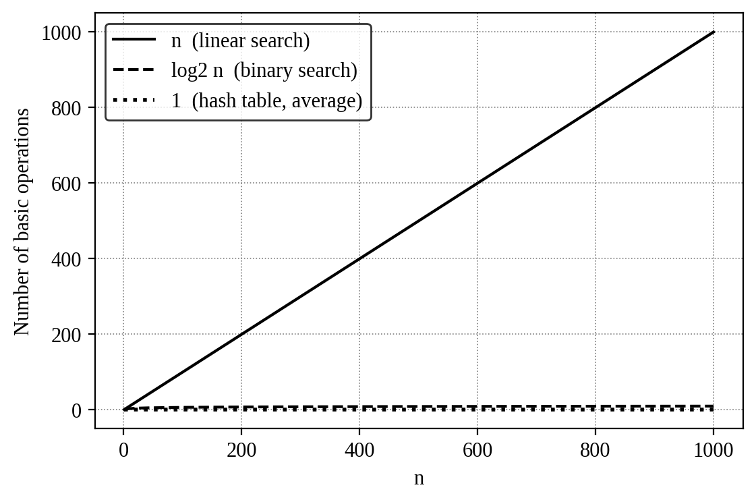
Figure 5: Growth of the three cost functions (theoretical)

Growth from 1,000 to 1,000,000 records (n becomes 1,000 times larger)
Algorithm | Comparisons at n = 1,000 | Comparisons at n = 1,000,000 | Growth factor | Meaning for the university
A. Linear | ≈ 500 | ≈ 500,000 | × 1,000 | Search time grows as fast as the database. A search that was instant becomes very slow.
B. Binary | ≈ 9 | ≈ 19 | about × 2 | Even a 1000-fold larger database needs only about 10 more comparisons.
C. Hash | ≈ 1.4 | ≈ 1.4 | × 1 (constant) | The size of the database hardly matters for the average search.
Table 6: Practical meaning of the growth rates
For very large n the order is clearly Θ(1) < Θ(log n) < Θ(n). The linear approach becomes impractical for million-record databases that are searched often, while logarithmic and constant growth remain practical even for many millions of records. Note that binary search and hashing must pay Θ(n log n) and Θ(n) once for preprocessing, which is why the number of searches matters (Task 12).

TASK 6 – Formulate the Recurrence Relation (3 Marks)
The recursive algorithm is binary search (Approach B). The recurrence is built by looking at what one call of BinarySearch does.
Component | Taken from the algorithm
Input size of the original problem | n = high − low + 1 = number of records still under consideration
Size of the recursive subproblem | After checking A[mid], only the left part (low … mid−1) or the right part (mid+1 … high) is searched. Its size is at most ⌊n/2⌋.
Number of recursive calls | Only ONE (the if / else-if chooses either the left or the right half, never both)
Work outside the recursive call | Compute mid and compare the key with A[mid] (and the range check): constant work = 1 basic operation
Base case | Empty range (low > high), n = 0: the call returns −1 without any comparison, so T(0) = 0. A range of one record needs one comparison: T(1) = 1.
Table 7: Components of the recurrence
Combining the components: the cost of a search on n records is the cost of one comparison plus the cost of searching a range of at most half the size. For the worst case (key absent or found last):
T(n) = T(⌊n/2⌋) + 1 for n ≥ 1, T(0) = 0
For n = 2ᵏ this is written T(n) = T(n/2) + 1 with T(1) = 1. Here a = 1 subproblem, of size n/b with b = 2, and the extra work f(n) = 1 = Θ(1).
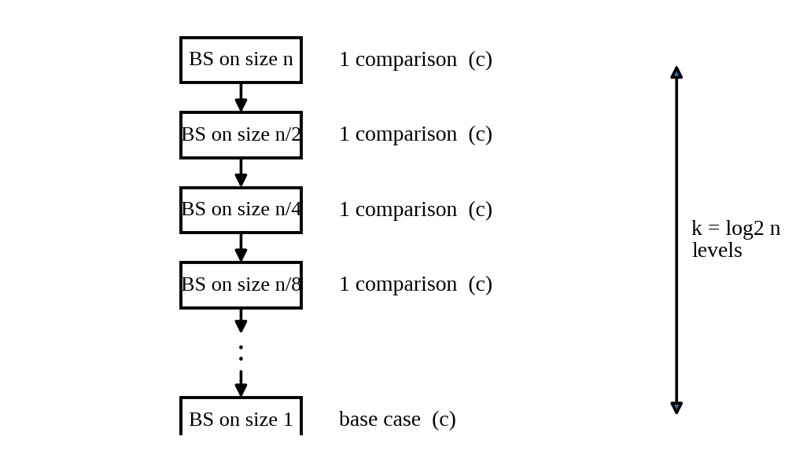
Figure 6: Recursion diagram – each level does 1 comparison and halves the range

TASK 7 – Solve the Recurrence Relation (4 Marks)
Method chosen: the iteration (backward substitution) method, checked with the Master Theorem and verified by induction (substitution). Iteration is suitable because the recurrence T(n) = T(n/2) + 1 has a single, simple recursive term, so the pattern appears after a few expansions. The Master Theorem applies because the recurrence has the form T(n) = aT(n/b) + f(n) with a = 1 ≥ 1, b = 2 > 1.

Step 1 – Iteration (take n = 2ᵏ)
Step | Expansion | Value
1 | T(n) = T(n/2) + 1 | T(n/2) + 1
2 | T(n/2) = T(n/4) + 1 | T(n/4) + 2
3 | T(n/4) = T(n/8) + 1 | T(n/8) + 3
… | … | …
k | T(n/2ᵏ⁻¹) = T(n/2ᵏ) + 1 | T(n/2ᵏ) + k
The recursion stops when n/2ᵏ = 1, i.e. k = log₂ n. Using T(1) = 1:
T(n) = T(1) + log₂ n = 1 + log₂ n
For general n (not a power of 2) the floor gives T(n) = ⌊log₂ n⌋ + 1, which agrees with the count derived in Task 3.

Step 2 – Master Theorem check
a = 1, b = 2, f(n) = 1. Compare f(n) with n^(log_b a) = n^(log₂ 1) = n⁰ = 1. Since f(n) = Θ(n⁰), Case 2 applies and T(n) = Θ(n⁰ · log n) = Θ(log n).

Step 3 – Verification by induction (substitution)
Claim: T(n) ≤ log₂ n + 1 for all n ≥ 1. Base: T(1) = 1 ≤ log₂ 1 + 1 = 1. ✓. Step: assume the claim for all smaller values. Then
T(n) = T(⌊n/2⌋) + 1 ≤ (log₂(n/2) + 1) + 1 = log₂ n − 1 + 1 + 1 = log₂ n + 1. ✓

Result and interpretation
- T(n) = Θ(log n) (exactly ⌊log₂ n⌋ + 1 comparisons in the worst case).
- For 1,000 records at most 10 comparisons are needed, for 1,000,000 records at most 20, and for 1,000,000,000 records only 30.
- Doubling the database adds only one more recursive call. The recursion depth is small (about 20), so there is no danger of stack overflow even for millions of records.

TASK 8 – Implement and Test the Algorithms (4 Marks)
All three algorithms were implemented in Python 3 exactly as in the pseudocode of Task 1 (file daa_search_experiment.py). Counters are placed at the basic operation (key comparison) so the experiments match the analysis of Tasks 2–7.

Core implementation
def linear_search(a, key):
comparisons = 0
for i in range(len(a)):
comparisons += 1
if a[i] == key: return i, comparisons
return -1, comparisons

def binary_search(a, key, low, high, count):
if low > high: return -1
mid = (low + high) // 2
count[0] += 1
if a[mid] == key: return mid
if key < a[mid]:
return binary_search(a,key,low,mid-1,count)
return binary_search(a,key,mid+1,high,count)

class HashTable:
def __init__(self, n):
self.m = int(n*1.3) | 1
self.table = [None]*self.m
def insert(self, key):
i = key % self.m
if self.table[i] is None: self.table[i] = [key]
else: self.table[i].append(key)
def search(self, key):
count = 1
chain = self.table[key % self.m]
if chain is None: return False, count
for x in chain:
if x == key: return True, count
count += 1
return False, count

Testing procedure (reproducible)
- Datasets: unique random 9-digit registration numbers generated with a fixed seed (2026) for n = 1,000; 10,000; 100,000 and 1,000,000. The same list of keys is given to all three algorithms: linear search uses it as it is, binary search uses a sorted copy, and the hash table is built from it.
- Queries: 200 searches per dataset – 100 keys that exist (chosen at random) and 100 keys that do not exist – shuffled, and identical for all algorithms.
- Measurements: comparisons are counted by the counters; running time is measured separately (without counters) with time.perf_counter() as the average time per search; sorting time and table-building time are measured once for each n.
- Correctness check: for every query the result of each algorithm is compared with the answer from a Python set. All 800 × 3 checks passed.
- To repeat: run python3 daa_search_experiment.py (runs the tests, then the benchmark).

Test cases
Test case | Example key | Expected | Linear | Binary | Hash
First record | 1050 | Found | PASS | PASS | PASS
Last record | 7080 | Found | PASS | PASS | PASS
Middle record | 4010 | Found | PASS | PASS | PASS
Absent, smaller than all | 10 | Not found | PASS | PASS | PASS
Absent, larger than all | 9999 | Not found | PASS | PASS | PASS
Absent, inside the range | 4500 | Not found | PASS | PASS | PASS
Database with 1 record (present) | 42 | Found | PASS | PASS | PASS
Database with 1 record (absent) | 7 | Not found | PASS | PASS | PASS
Random 1,000 – 1,000,000 records | 200 per size | Same as set | PASS | PASS | PASS
.

TASK 10 – Compare Theory with Experimental Behaviour (4 Marks)
Measure (n = 1,000,000) | Theory | Experiment | Agreement
Linear search, successful (comparisons) | (n + 1)/2 = 500,000.5 | 485,879 | Within 2.8% (random sample of 100 keys)
Linear search, unsuccessful | n = 1,000,000 | 1,000,000 | Exact
Binary search, successful | log₂(n+1) − 1 ≈ 18.9 | 18.93 | Very close
Binary search, worst case | ⌊log₂ n⌋ + 1 = 20 | 20 | Exact
Hash, successful | 1 + α/2 ≈ 1.38 | 1.26 | Close
Hash, unsuccessful | 1 + α ≈ 1.77 | 1.75 | Close
Table 12: Theoretical prediction versus measured comparisons

Does the observed growth agree with theory?
- Yes, for the number of comparisons. Linear search grew from 485 to 485,879 comparisons (about 1,000 times, as n did). Binary search grew only from 9.0 to 18.9 (it gained about 1 comparison each time n doubled). Hash search stayed near 1.3–1.5.
- Time follows the same ranking but not the exact ratios. From n = 1,000 to 1,000,000 the time per search rose by about ×1,250 for linear search (theory: ×1,000), ×4.3 for binary search (theory: about ×2) and ×6.5 for hashing (theory: ×1).

Which scales better?
The hash table scales best, then binary search; linear search scales worst. At n = 1,000,000 the average time per search was 9.98 ms for linear search, 5.22 µs for binary search and 0.75 µs for the hash table. Binary search is about 1,914 times faster than linear search, and hashing is about 7.0 times faster than binary search.

Differences between prediction and experiment, and reasons
- Memory and cache effects: small arrays fit in the processor cache, but 1,000,000 records do not. Binary search and hashing jump to scattered memory locations, so each step costs more at large n. This explains why their times grow even though their comparison counts barely change.
- Constant factors and language overhead: Python executes each loop iteration, function call and list access slowly. Recursive calls in binary search cost more than the simple loop of linear search per step, and the hash search has extra work (the mod calculation and list access) that Big-O ignores.
- Random sampling: only 100 successful keys were used per size, so the measured average differs a little from (n + 1)/2. The hash chain lengths vary randomly around the expected α.
- Timing noise and mixed queries: timings include system noise, and half of the queries were unsuccessful, which is the worst case for linear search.

TASK 11 – Recommend and Defend the Final Design (4 Marks)
Recommendation: Approach B – Binary search on a sorted array of registration numbers (sorted once with merge sort).
Criterion | A. Linear | B. Binary | C. Hash
Average search (n = 10⁶) | 485,879 comparisons; 9.98 ms | 18.9 comparisons; 5.22 µs | 1.26 comparisons; 0.75 µs
Worst-case guarantee | n (bad) | 20 – guaranteed | n (if many collisions)
Preprocessing (n = 10⁶) | none | 0.31 s | 1.96 s
Extra memory | none | none (sorts in place) | ≈ 30% more slots plus links
Ordered queries (ranges, sorted reports) | No | Yes | No
Needs sorted / restructured data | No | Yes | Yes
Table 13: Evidence used for the recommendation

Why binary search is more appropriate than the alternatives
- Versus linear search: it is about 1,914 times faster at n = 10⁶ in our experiment. Its sorting cost (0.31 s) is paid back after only about 31 searches, so it is clearly better for any database that is searched repeatedly.
- Versus hashing: hashing is faster per search, but binary search has a guaranteed worst case (20 comparisons) that does not depend on the quality of a hash function, needs no extra memory, has a cheaper preprocessing step (0.31 s versus 1.96 s) and also supports sorted listings and range queries (e.g. all students of one batch), which a university often needs.

Theoretical and experimental efficiency
Theory: preprocessing Θ(n log n) once, then Θ(log n) per search (T(n) = T(n/2) + 1). Experiment: about 18.9 comparisons and 5.22 µs per search at n = 1,000,000, with a maximum of 20 comparisons, exactly as predicted.

Trade-offs and limitations
- The data must stay sorted. Inserting a record into the middle of a sorted array costs Θ(n), so frequent insertions would need a different structure (for example a balanced search tree) or periodic re-sorting.
- The preprocessing is a Θ(n log n) investment that is worthwhile only when many searches follow.

TASK 12 – Day-4 Design Challenge: Re-evaluate and Adapt the Design (8 Marks)

A. Impact Analysis (2 Marks)
Aspect | Original problem | Changed requirement
Search load | Not specified; a few searches per record set | 50,000 per hour ≈ 13.9 per second ≈ 1,200,000 per day
Database size | 1,000 growing to 1,000,000+ | Fixed at 1,000,000 records
Updates | Unspecified | New records only once per day – data is static for 24 hours
What matters most | One-time preprocessing counted fully | Per-search cost is multiplied by 1.2 million; preprocessing is shared by all of them
Table 14: What has changed
- Assumptions affected: the assumption that preprocessing is a large part of the total cost no longer holds. A one-time cost of a few seconds is divided over 1.2 million searches, and any small saving per search is multiplied 1.2 million times.
- Why search frequency is now important: total cost = preprocessing + (number of searches × cost per search). With Q = 1,200,000 the second term dominates, so the cost per search is the deciding factor.
- Why rare updates matter: the data does not change during the day, so a sorted array or hash table built once a day stays perfectly valid. The weaknesses of these structures (costly insertion into a sorted array, rebuilding a table) are avoided, and the daily rebuild can be done at night.

B. Evaluation of the Original Design (2 Marks)
The original design (sorted array + binary search) is evaluated with the measured values at n = 1,000,000:
Approach | Time per search | CPU time for 50,000 searches (1 hour) | Preprocessing (once a day) | Total CPU time for one day (1.2 million searches)
A. Linear | 9.98 ms | 499.1 s (13.9% of one core) | none | 11,977 s (≈ 3.3 hours)
B. Binary (original) | 5.22 µs | 0.26 s | 0.31 s | 6.6 s
C. Hash table | 0.75 µs | 0.038 s | 1.96 s | 2.9 s
Table 15: Behaviour under 50,000 searches per hour (measured in Python)
- Behaviour under the load: binary search easily handles 13.9 requests per second – the whole hour of searches takes under half a second of CPU time. The original design is therefore still correct and adequate.
- Is the preprocessing acceptable? Yes. Sorting takes 0.31 s once a day, which is only 0.26 µs per search when spread over 1.2 million searches.
- Could another approach be better overall? Yes – hashing. Its build cost is higher (1.96 s) but each search is about 7.0 times cheaper. The extra build time is recovered after about 368,140 searches (≈ 7.4 hours of traffic), i.e. well within one day, and hashing has the lowest total daily cost. Linear search is unsuitable: it would use about 13.9% of a CPU core just for searching and its cost grows with every new record.

C. Adaptation or Redesign (2 Marks)
Decision: MODIFY the original design (keep the sorted array, add a hash index).
- Revised strategy: (1) every night, sort the day's new records (k records, small) and merge them into the sorted array in O(n + k) time instead of re-sorting everything; (2) build a hash index (registration number → record position) in Θ(n); (3) during the day, answer every search with the hash index (average O(1)); (4) keep the sorted array for range queries, sorted reports and as a fallback.
- What has changed: the main search structure changes from binary search (recursive, O(log n)) to a hash lookup (O(1) average). The sorted array is retained, so the original design is extended and not thrown away.
Cost | Original design | Modified design
Nightly preprocessing | Θ(n log n) sort | Θ(n + k) merge + Θ(n) hash build = Θ(n)
One search (average) | Θ(log n) ≈ 19 comparisons | Θ(1) ≈ 1.3 comparisons
Total for Q searches per day | Θ(n log n + Q log n) | Θ(n + Q)
Measured daily CPU time | 6.6 s | 2.9 s
Table 16: Effect of the modification on computational complexity

D. Evidence-Based Defence (2 Marks)
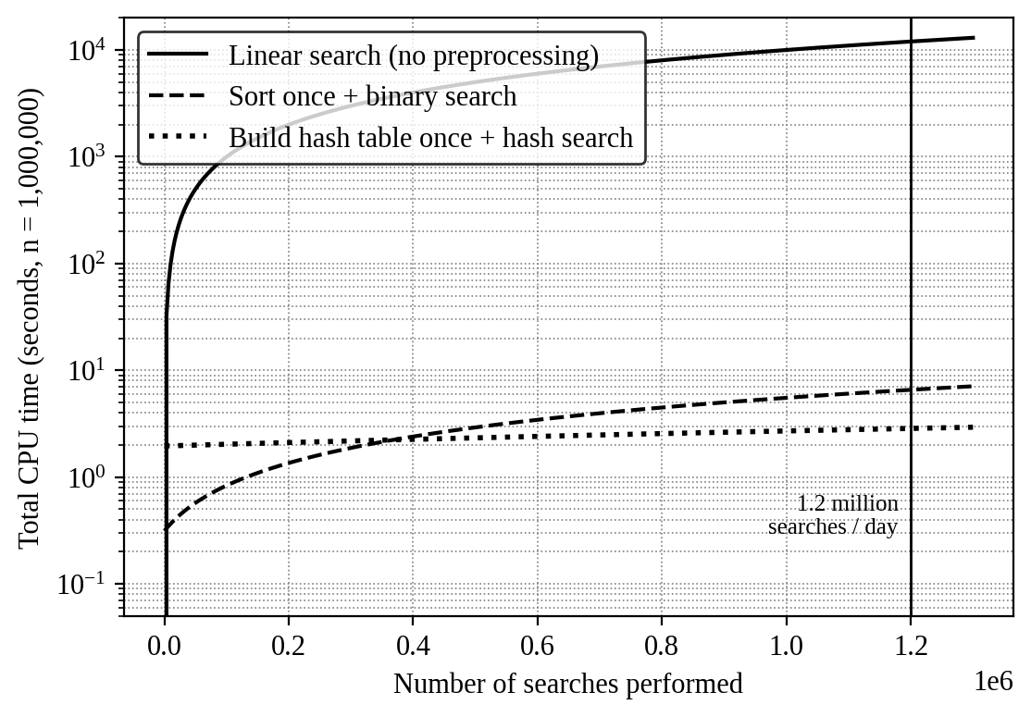
Figure 10: Total CPU cost of searching 1,000,000 records as the number of searches grows
Evidence | Observation | Conclusion
Search frequency | 1,200,000 searches/day (13.9 per second) | Per-search cost dominates; linear search rejected
Complexity | O(1) average for hash vs O(log n) for binary vs O(n) for linear | Hash gives lowest cost growth
Preprocessing cost | 0.31 s (sort) and 1.96 s (hash build), once a day | Negligible when shared by 1.2 million searches
Experiment | Binary 5.22 µs, hash 0.75 µs per search (Figure 8) | Hash about 7.0 times faster; linear 10.0 ms
Break-even | Sorting pays off after about 31 searches; hash overtakes binary after about 368,140 searches | Both reached within the first hours of a day
Dataset size / updates | n = 10⁶; updates once a day | Static data, so the hash index never goes stale during the day
Table 17: Evidence summary
Final decision: use the modified design – a hash index rebuilt every night for exact-match searches, with the sorted array retained. It follows logically from the analysis: searches are frequent (so the cost per search matters), updates are rare (so the preprocessing is cheap per search and the index remains valid), and the experiment confirms the lowest total cost.
Trade-offs and limitations: the hash index needs about 30% extra memory and, in the worst case (very poor hash function or deliberately colliding keys), degrades towards Θ(n); this is reduced by using a good hash function and a prime or odd table size, and the sorted array provides a safe fallback. Honest note: the required load of 13.9 searches per second is so small that even the original binary search design would meet it with a very large safety margin; the

